Set up Temp JSON API

We required json-server module

Install it: npm install json-server –g

Once the installation done successfully execute below command to create new json file.

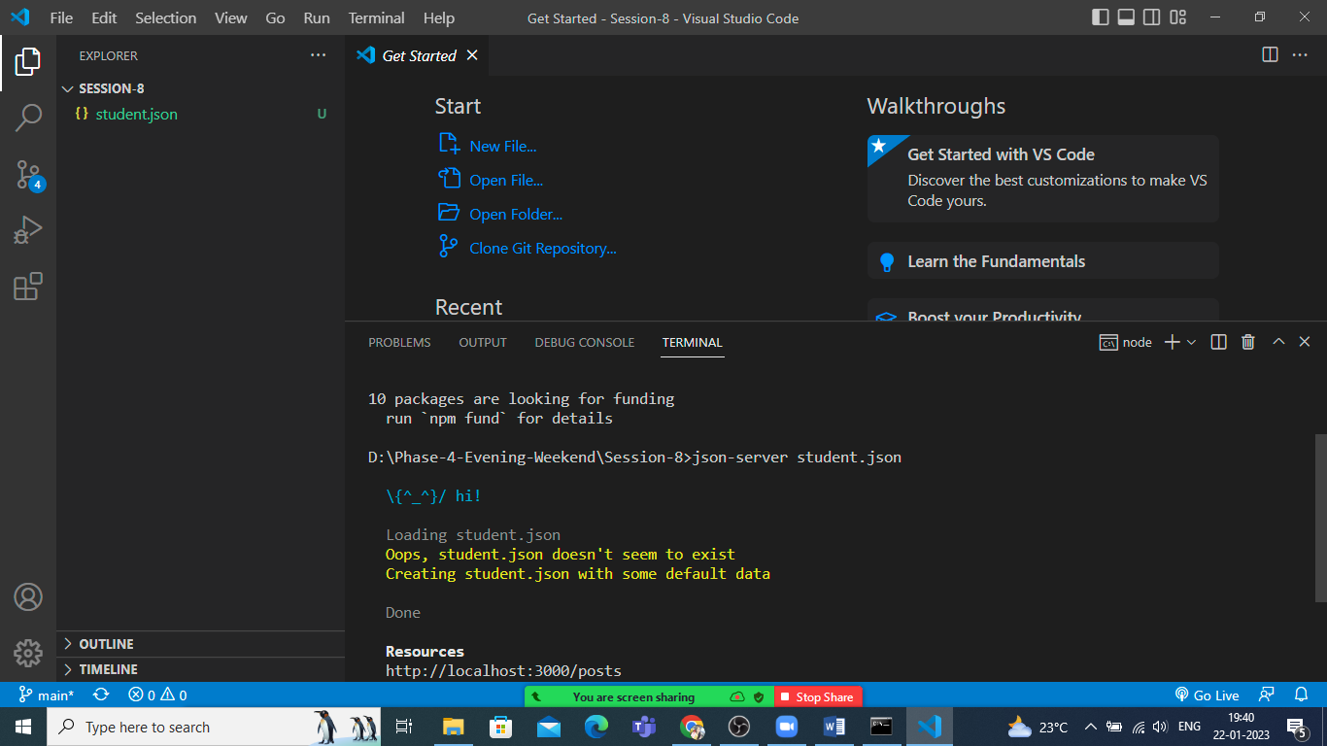

It will create a new file names student.json

Open and edit as below.

{

  "students": [

    {

      "id": 1,

      "name": "sonam",

      "email": "sonam@gmail.com",

      "country":"india"

    }

  ]

}

Reload the same again

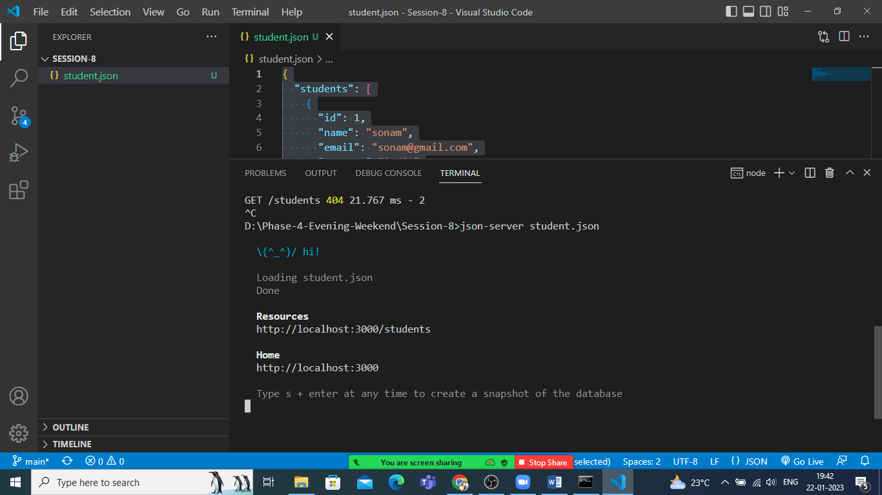

You can check the API using <http://localhost:3000/students> to get all data

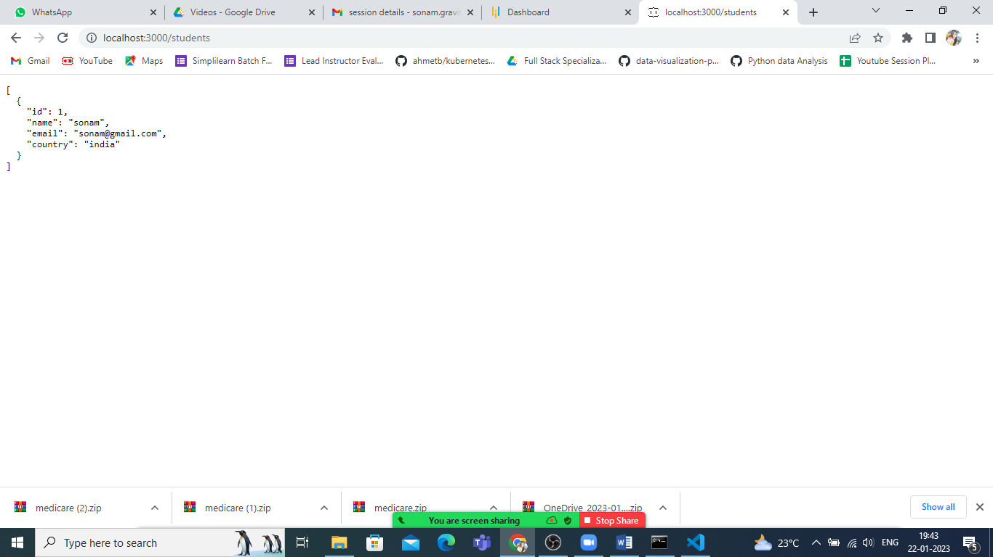

Post Request

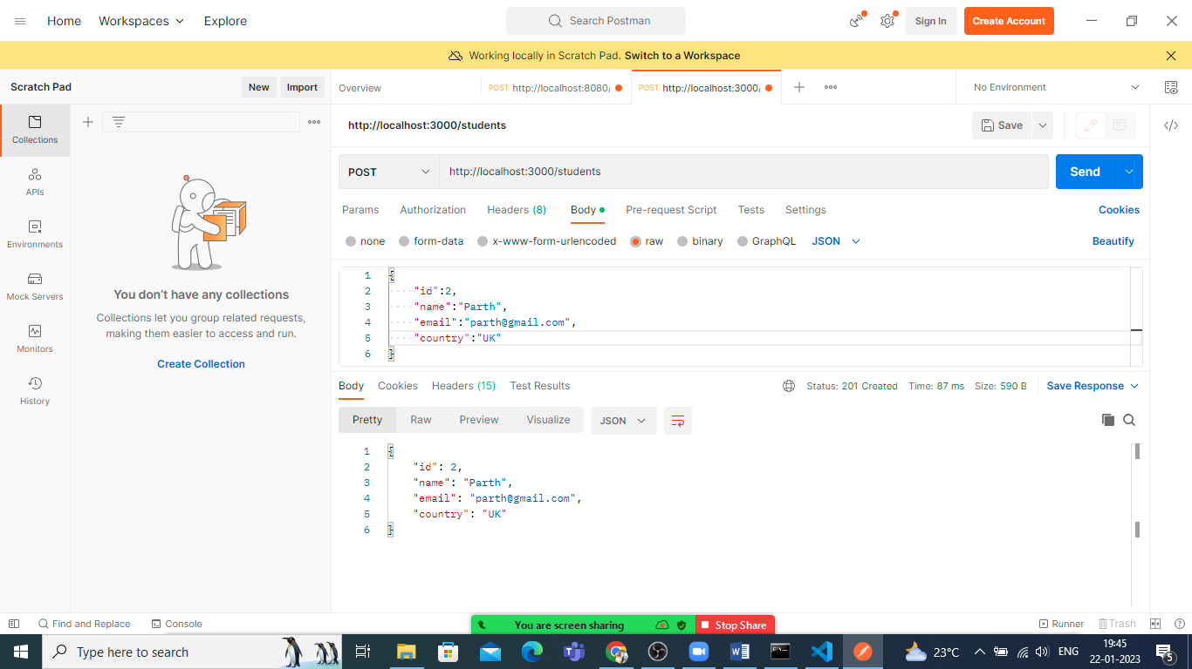

Put Request

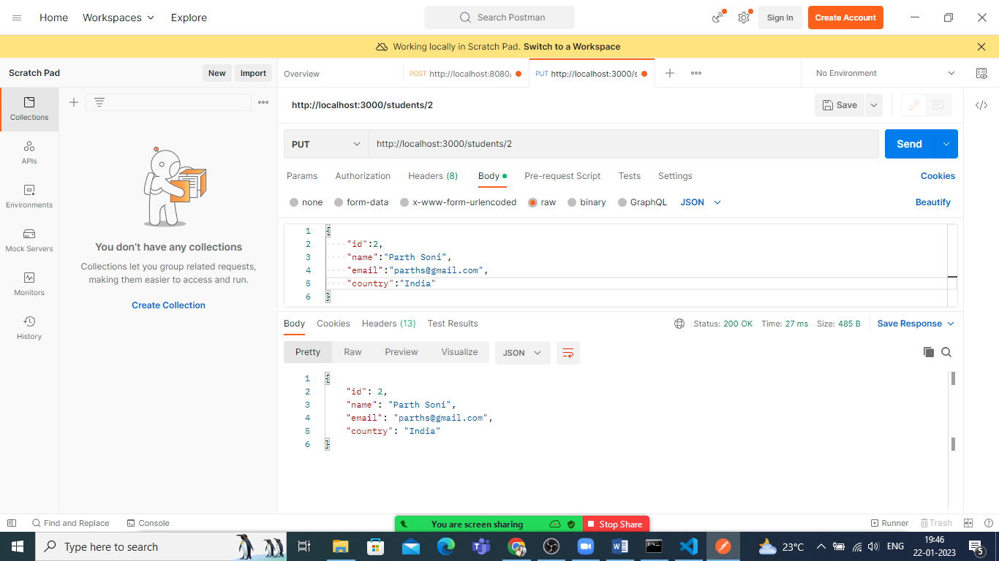

Get By Id Request

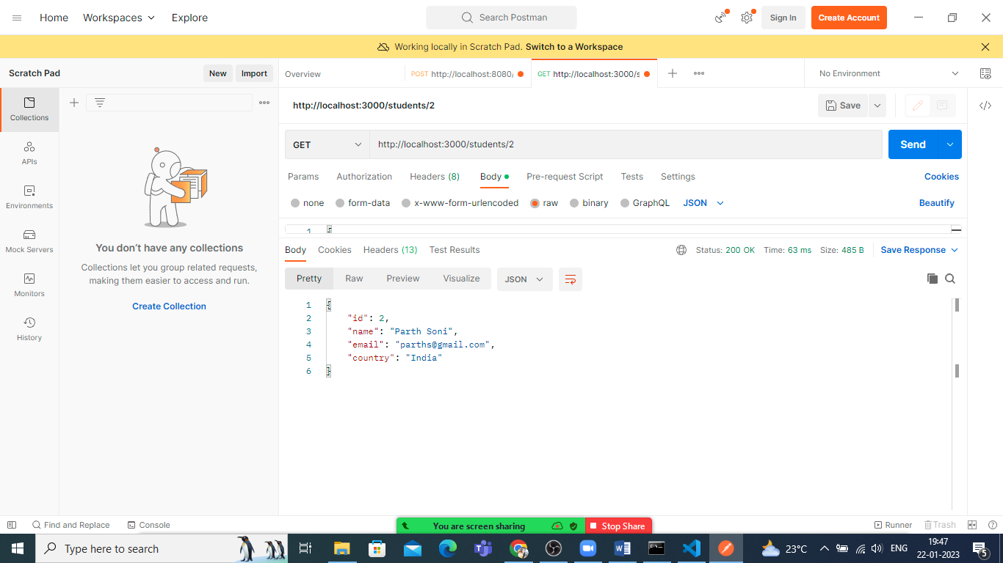

Delete Request

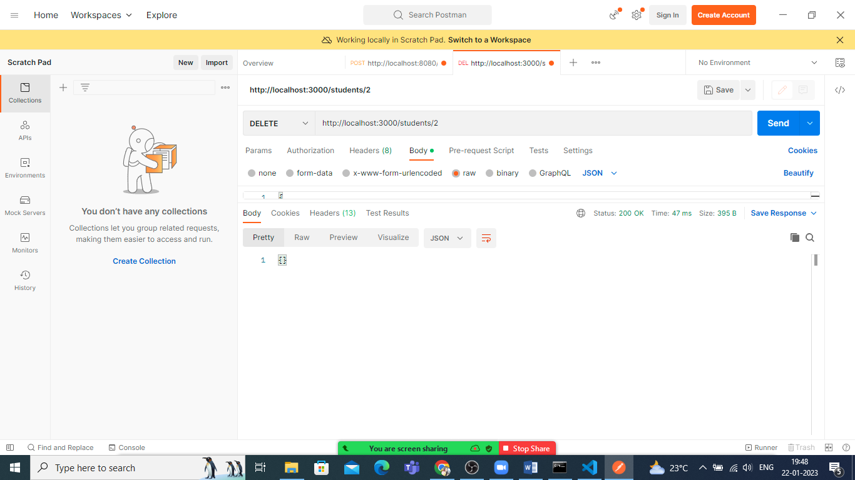

Let’s Work with this API in Angular.